

CARBON REDUCTION PLAN GUIDANCE

Notes for Completion
Where an In-Scope Organisation has determined that the measure applies to the procurement, suppliers wishing to bid for that contract are required at the selection stage to submit a Carbon Reduction Plan which details their organisational carbon footprint and confirms their commitment to achieving Net Zero by 2050.
Carbon Reduction Plans are to be completed by the bidding supplier entity and must meet the reporting requirements set out in supporting guidance, and include the supplier’s current carbon footprint and its commitment to reducing emissions to achieve Net Zero emissions by 2050.
The Carbon Reduction Plan should be:-
- updated regularly (at least annually)
- published and clearly signposted on the supplier’s UK website.
- approved by a director (or equivalent senior leadership) within the supplier’s organisation to demonstrate a clear commitment to emissions reduction at the highest level.
Suppliers may wish to adopt the key objectives of the Carbon Reduction Plan within their strategic plans.
A template for the Carbon Reduction Plan is set out below.
Please complete and publish your Carbon Reduction Plan in accordance with the reporting standard published alongside this PPN.
Procurement Policy Note 06/21: Taking account of Carbon Reduction Plans in the procurement of major government contracts - GOV.UK (www.gov.uk)

Carbon Reduction Plan Template
Supplier name: Walker Construction (UK) Ltd.
Publication date: 9th April 2025

Commitment to achieving Net Zero

Walker Construction (UK) Ltd. is committed to achieving Net Zero emissions by 2040.

Baseline Emissions Footprint
Baseline emissions are a record of the greenhouse gases that have been produced in the past and were produced prior to the introduction of any strategies to reduce emissions. Baseline emissions are the reference point against which emissions reduction can be measured.

Baseline Year: January – December 2023
Baseline year emissions:
EMISSIONS | TOTAL (tCO₂e)
Scope 1 | 1556
Scope 2 | 17
Scope 3  (All Scope 3 Emissions) | 13,187
Total Emissions | 14,760

Current Emissions Reporting

Reporting Year: January – December 2024
EMISSIONS | TOTAL (tCO₂e)
Scope 1 | 1523
Scope 2 | 15
Scope 3  (All Scope 3 Emissions) | 11,195
Total Emissions | 12,733

Emissions reduction targets
Walker Construction (UK) Ltd. have carried out a full year carbon audit of our Scope 1,2 & 3 carbon emissions for 2024 and compared this against our 2023 benchmark. We have an action plan in place to reduce our emissions by half by the end 2030 in line with government targets and the SBTi to limit global warming to 1.5 Degrees Celsius.

Our objective is to be a ‘Net Zero’ business by 2040.

From our 2023 Baseline we project that carbon emissions will decrease over the next five years to 7380 tCO2e by the end of 2030. This is a reduction of 50%

Scope 1 Emissions Against 2023 Baseline
• Scope 1 Site Fuel. Reduction target 778 tCO2e by end 2030 or 111 tCO2e/year

Scope 2 Emissions Against 2023 Baseline
• Scope 2 Office Energy. Reduction target 17 tCO2e by end 2025

Scope 3 Emissions Against 2023 Baseline
• Scope 3 Sub-Contractors. Reduction target 4205 tCO2e by end 2030 or 601 tCO2e/year
• Scope 3 Direct Materials. Reduction target 2289 tCO2e by end 2030 or 327 tCO2e/year

• Scope 3 Waste. Reduction target 35 tCO2e by end 2030 or 5 tCO2e/year

• Scope 3 Daily Operations. Reduction target 65 tCO2e by end 2030 or 9 tCO2e/year

Progress against these targets can be seen in the graph below:

Carbon Reduction: Projected 2025-2030 & ‘Net Zero’ 2040

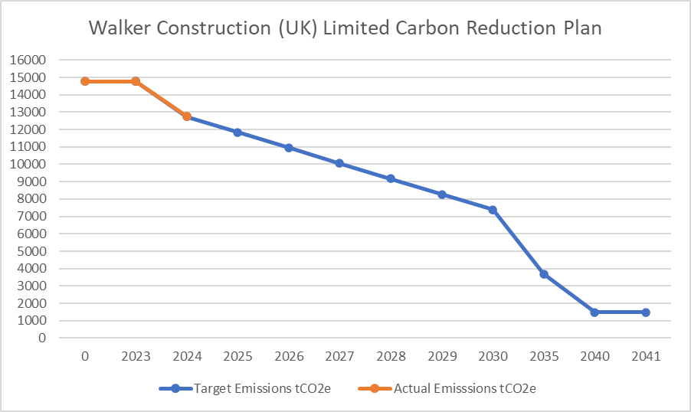

Carbon Reduction Initiatives
The following environmental management measures and projects have been completed or implemented since the 2023 baseline. The 2024 total carbon emissions reduction achieved by these initiatives equate to 2027 tCO₂e, a 14% reduction against the 2023 baseline. The following measures will be in effect when performing the contract;
Scope 3 Supply Chain Initiatives.
Sub-contractors now account for 59% of our total emissions (58% in 2023).
In 2023 we kick-started our sub-contractor ‘emissions engagement initiative’ - requesting information relating to our emissions footprint from our Top 55 suppliers that account for 79% of our total sub-contractor spend (2024 audit pareto purchasing data).
This will continue to be a key strategic thrust for the business in 2025 as we seek to build on this dialogue with our key partners to drive down emissions on projects through closer collaboration and investigation of lower carbon alternatives as well as the accurate measurement of our supply chain emissions. (see also below).
‘Upfront’ carbon’ is a significant construction industry emissions contributor globally. Steel, insulation, bricks, timber, concrete in particular are the primary contributors here in terms of CO2e.

We have reduced our emissions associated with ‘Direct Purchases’ of building materials by 24% in 2024 or 1120 tCO2e. The sourcing of ‘lower carbon’ alternatives must continue to be a priority at ‘estimating’ stage helping to facilitate more informed client decision making on emissions reduction.
New for 2024 we have identified spend by procurement category/taxonomy to enable us to drill down further into our supply chain emissions and work more closely with both our direct materials suppliers and sub-contractors.
We now need to ensure this message is re-enforced through our estimating/buying teams with lower carbon solutions feeding into our final tendering proposals supported by our ‘Causeway’ software solution enabling us to put forward ROI vs. emissions reduction based arguments to our clients.
In 2023/24 we have been part of a consortium building a new ‘modular’ footbridge solution for railway platforms. In order to make the project as sustainable as possible we have used recycled steel in it’s construction.
Using Gov.UK conversion factors, and knowing the weight of steel used, we have been able to calculate a direct saving of 125 tCO2e alone for this single prototype project.
In total we have saved an additional 855 tCO2e through our subcontractor emissions reduction initiatives in 2024.
Scope 3 Waste Emissions Initiatives.
We have reduced our associated waste emissions by 10 tonnes or 14% in 2024 through smarter use of initiatives like soil stabilisation and re-use of materials on site e.g. crushing. This has significantly reduced the need for ‘muck-away’ waste removal and is an important ‘circularity’ objective.
As part of our sustainability strategy training away day held on April 18th, 2024, we identified three business process opportunities to;
1. drive greater ‘uptake’ of soil stabilisation activity on site
2. carry out more on-site processing of waste materials e.g. hardcore where possible for direct reuse as part of the construction process
3. deliver ‘bio-diversity net gain’ through the creation of nature areas by working more closely with developers and local/planning authorities
We will continue to look for intelligent ways to further reduce our emissions here in 2025.
Scope 3 Daily Operations Initiatives.
We have reduced our emissions here by 7 tCO2e in 2024.
As with Scope 1, fuel emissions associated with business mileage and employee commuting are the most significant emissions centres. We will look to introduce a ‘two tier’ car allowance moving forwards to incentivise the purchase of lower emissions vehicles under a certain age.

Scope 2 Initiatives
Good progress has been made in 2024 with a 12% (2 tCO2e) reduction in associated emissions. Reducing our office (Scope 2) emissions through the investment in Solar PV at the Lympne office in particular has paid dividends. We expect to this reduction in office emissions increase significantly in 2025 our first full year of installation and will also move to a Green energy Tariff in 2025 for our second office in the Midlands in effect removing our office emissions completely.
Scope 1 Initiatives
Scope 1 emissions from company vehicles and site fuel usage remain a challenge. Despite this we have generated 33 tCO2e savings overall during 2024.
Our EV salary sacrifice scheme has proved largely ineffectual due to the nature of the often long distances our staff need to travel and the practicalities of charging on the go! At present EV’s do not make sense for our business and as such staff take up has been low! Take up of non EV company car options has actually increased in the business, with a corresponding decline witnessed in private vehicle business mileage.
HVO/Bio Fuel remains at a 25% cost premium and unless we have a specific mandate from our client to use this as a ‘greener’ fuel alternative, cost pressures dictate we use more traditional diesel fuel. 99 tCO2e savings were made during the year as a result of overall lower consumption of site fuel.
Commercial vehicle emissions have decreased by 14 tonnes CO2e and our ‘stay away’ policy for commuting distances of 2+ hours is an important factor here.
ISO 14001 & 9001 accreditation is already in place and we will work towards maintaining this year on year.

Declaration and Sign Off
This Carbon Reduction Plan has been completed in accordance with PPN 06/21 and associated guidance and reporting standard for Carbon Reduction Plans.
Emissions have been reported and recorded in accordance with the published reporting standard for Carbon Reduction Plans and the GHG Reporting Protocol corporate standard and uses the appropriate Government emission conversion factors for greenhouse gas company reporting.
Scope 1 and Scope 2 emissions have been reported in accordance with SECR requirements, and the required subset of Scope 3 emissions have been reported in accordance with the published reporting standard for Carbon Reduction Plans and the Corporate Value Chain (Scope 3) Standard.
This Carbon Reduction Plan has been reviewed and signed off by the board of directors (or equivalent management body).

Signed on behalf of the Supplier:
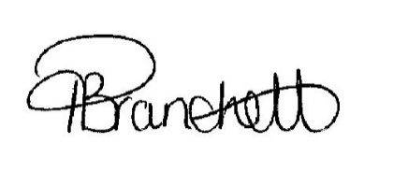
………………………………………………………………….
Date: …01/04/2025…………………….……….

https://ghgprotocol.org/corporate-standard
https://www.gov.uk/government/collections/government-conversion-factors-for-company-reporting
https://ghgprotocol.org/standards/scope-3-standard

